1x2 Filter PM Fiber Standard Coupler

1. Features
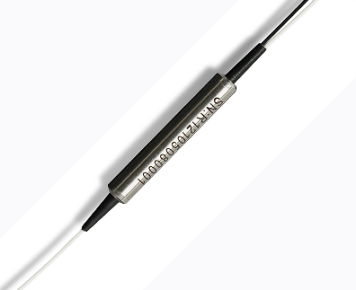

- Low Insertion Loss
- Low Extinction Ratio
- Available for Slow Only or Fast Axis App
- High Stability and Reliability

2. Applications
- EDFA
- Fiber Optical Instrument
- Coherent Communication
- Power Monitoring
- Fiber Sensor

3. Specifications
Parameters |  | Unit | 1 x 2
Splitting Ratio |  | nm | 50/50
Operating Wavelength |  | nm | 1310/1550
Operating Bandwidth |  | nm | ±40
Insertion loss |  | nm | ≤3.8
Extinction Ratio |  | dB | ≥20
Return Loss |  | dB | ≥50
Power Handling |  | mW | ≤500
Operating Temperature |  | ℃ | -10~+65
Storage Temperature |  | ℃ | -40～+85
Fiber Type |  | / | Corning Panda fiber
Fiber Length |  | m | 1.0±0.1m， others on request
Connector |  | / | FC/APC,FC/UPC， others on request
Package Dimension | 250μm Bare Fiber | mm | φ3.0×35
Package Dimension | 900μm Loose Tube | mm | φ3.0×38
Package Dimension | 2mm/3mm  Loose Tube | mm | 90×20×10

Splitting Ratio | Unit | Insertion loss
Splitting Ratio | Unit | 1 x 2
50/50 | dB | ≤3.8
20/80 | dB | ≤8.2/1.7
10/90 | dB | ≤11.8/1.0
5/95 | dB | ≤14.9/0.9
1/99 | dB | ≤22.2/0.6

*Above specifications are for devices with the connectors.
*The PM fiber and the connector key are aligned to the slow axis, fast axis is blocked

4．Package Dimension
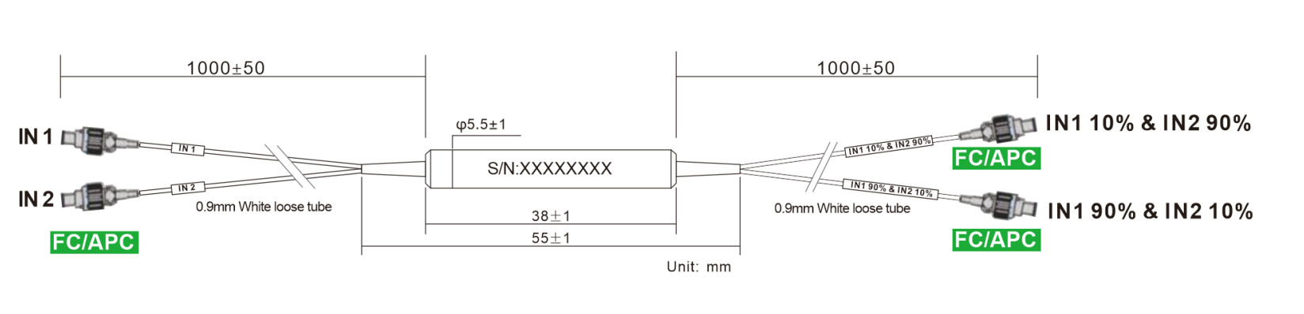

5. Ordering information
Couper | - | XXX | XXX | XX | XXX | XX | XX | - | X | X
 |  | Port NO | Wavelength | Splitting Ratio | Modules type | Fiber Type | Fiber Length |  | Com  connector | Port  Connector
PMC=  PM  Coupler |  | 12=1X2 | 131=1310nm | 50=50/50 | ST1=Ф5.5X35 | 02=250um fiber | 10=1.0m |  | 0=None | 0=None
PMC=  PM  Coupler |  | 22=2X2 | 155=1550nm | 10=10/90 | ST2=Ф5.5X38 | 09=0.9mm Tube | XX=Customized |  | 1=FC/UPC | 1=FC/UPC
PMC=  PM  Coupler |  |  | 980=980nm | 01=01/99 | SB=90 X20 X10 | 20=2.0mm Tube |  |  | 2=FC/APC | 2=FC/APC
 |  |  | 106=1064nm |  | XX=Customized | 30=3.0mm Tube |  |  | 3=SC/UPC | 3=SC/UPC
 |  |  | 780=780nm |  |  | XX=Customized |  |  | 4=SC/APC | 4=SC/APC
 |  |  |  |  |  |  |  |  | 5=LC/UPC | 5=LC/UPC
 |  |  |  |  |  |  |  |  | 6=LC/APC | 6=LC/APC
 |  |  |  |  |  |  |  |  | X=Customized | X=Customized

Part Number | Product Description
PMC-1215510ST20910-22(S) | 1*2 Filter PM Fiber Coupler，Splitting Ratio 50/50,Steel Tube type,  PM 1550nm Panda fiber With 0.9mm Hytrel Blue Tube,  fiber Length 1m (with connector)， connector FC/APC，  connector key is aligned to slow axis.

